Artificial Intelligence & Machine Learning

Introduction
Project Title: rising waters: a machine learning approach to flood prediction

Team Members:
Team ID : LTVIP2026TMIDS24632
Team Leader : Bankuru Chinnama Naidu
Team member : Muvvala Darshith Krishna
Team member : Uppada Sagar
Team member : Tummala Lakshmi Narasamma

Project Overview

Purpose:
The primary purpose of this research project is to develop a reliable and data-driven flood prediction system using machine learning techniques. Floods are one of the most devastating natural disasters, causing loss of life, damage to infrastructure, agricultural destruction, and economic instability. Traditional flood forecasting methods often rely on complex hydrological models and manual monitoring systems, which may be time-consuming and require extensive domain expertise. This project addresses these challenges by leveraging historical rainfall and climatic data to build an intelligent predictive model capable of identifying potential flood events efficiently and accurately.
The system analyzes important environmental parameters such as cloud cover and seasonal rainfall distribution to detect patterns associated with flood occurrences. Multiple machine learning algorithms are implemented and compared to determine the most effective model for classification. By evaluating performance metrics such as accuracy, precision, recall, and F1-score, the study ensures that the selected model provides reliable and consistent predictions.
Another key purpose of the project is to bridge the gap between theoretical machine learning research and practical implementation. The trained model is integrated into a user-friendly web application that allows real-time prediction through a simple interface. This enhances accessibility and usability, making the system suitable for disaster management authorities, researchers, and policy makers.
Ultimately, the project aims to contribute to disaster risk reduction strategies by providing an automated early-warning support tool. Through predictive analytics, the system helps in proactive planning, better resource management, and minimizing the adverse impact of floods on society and infrastructure.

Features:
    - Data-Driven Prediction Model
The system utilizes historical rainfall and climate-related parameters to predict flood occurrence using advanced machine learning algorithms.

    - Multiple Algorithm Comparison
Implements and evaluates various classification models such as KNN, Decision Tree, Random Forest, and XGBoost to identify the most accurate predictive model.
    - Feature-Based Analysis
Analyzes important environmental factors including cloud cover and seasonal rainfall patterns to capture flood- related trends and relationships.
    - Performance Evaluation Metrics
Evaluates models using accuracy, precision, recall, F1-score, confusion matrix, and ROC curve to ensure reliability and robustness.
    - Real-Time Web-Based Interface
Provides a user-friendly Flask-based web application where users can input rainfall parameters and receive instant predictions.
    - Interactive Result Display
Displays prediction outcomes through a professional popup interface, enhancing user experience and clarity.
    - Scalable and Deployable Architecture
Designed with modular architecture, allowing future integration with real-time weather APIs, cloud platforms, or geographic information systems.
    - Early Warning Support Tool
Acts as a decision-support system to assist disaster management authorities in early planning, resource allocation, and risk mitigation.

Architecture
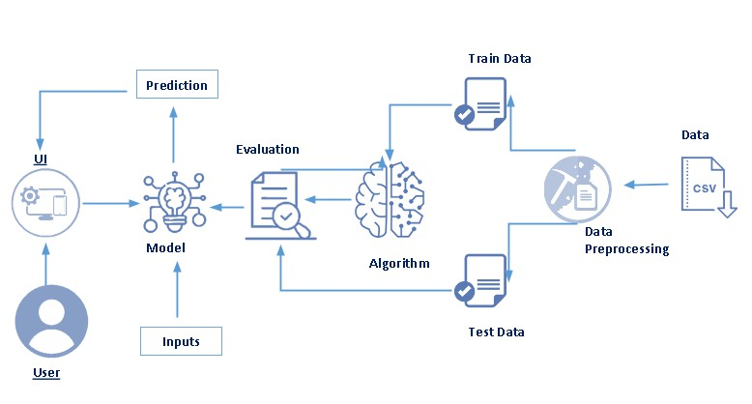
Figure 1: System Architecture

Data Collection
The system begins with the collection of historical environmental and rainfall data obtained from reliable sources. The dataset contains parameters such as rainfall measurements, cloud cover, temperature-related seasonal indicators, and other climatic attributes. These data are stored in structured CSV files and form the foundation for building the predictive machine learning model.

Data Preprocessing
Before model training, the collected raw data undergo preprocessing to ensure quality and consistency. This stage involves cleaning missing values, removing duplicate records, selecting relevant features, and applying normalization or scaling techniques. Proper preprocessing improves model accuracy and ensures stable performance during prediction.

Training Data
After preprocessing, the dataset is divided into training and testing subsets. The training data are used to train the machine learning algorithms so that they can learn patterns and relationships between environmental factors and historical flood occurrences. This learning process enables the model to identify complex dependencies among the input features.

Testing Data
The testing dataset consists of unseen samples that are not used during training. It is employed to measure how well the trained model performs on new data. Testing ensures that the model is capable of generalizing its learned patterns rather than simply memorizing the training dataset.

Algorithm (Model Development)
Multiple machine learning algorithms (KNN, Decision Tree, Random Forest, XgBoost) are applied to the prepared dataset to develop predictive models. Each algorithm processes the training data, learns decision rules, and builds a classification structure capable of determining whether a flood event is likely to occur based on environmental inputs. The model with the best performance is selected for deployment. XgBoost shows the better performance and ideally good for unseen data.

Working Process of XGBoost in the Flood Prediction Model:

Step 1: Data Preparation
The flood dataset is cleaned, required features are selected, and the data is split into training and testing sets for model learning and evaluation.

Step 2: Initial Prediction
XGBoost starts with an initial prediction and calculates the errors between predicted and actual flood values.

Step 3: Boosting Process
Multiple decision trees are built sequentially, where each new tree learns from the previous errors to improve prediction accuracy.

Step 4: Final Prediction
All trees are combined to generate the final output, predicting whether a flood is expected or not for the given input data.

Evaluation
The trained models are evaluated using statistical performance measures to determine their prediction capability. This evaluation stage verifies the reliability of the model by comparing predicted outputs with actual results from the test dataset, ensuring that the selected model provides consistent and accurate predictions.

Final Model

After evaluation, the best-performing algorithm is finalized and saved as the deployed prediction model. This model is integrated into the application backend so that it can process real-time user inputs and generate predictions efficiently.

User Inputs
Users interact with the system through a web interface where they provide rainfall and climate-related parameters. These inputs are validated and transformed into the required numerical format before being forwarded to the prediction model.

Prediction
The trained model analyzes the processed input data and produces the prediction result indicating whether a flood is expected or not. The output is then transmitted to the frontend interface for presentation to the user.

User Interface
The system interface provides a user-friendly environment where users can access the application homepage, enter prediction parameters, and view results in an interactive popup format. The interface ensures ease of navigation and enhances overall usability of the flood prediction system.

Setup Instructions

Prerequisites
Before running the Flood Prediction System, ensure that the required software and tools are installed on your system. The backend requires Python (3.8 or above) to run the Flask server and machine learning model. The frontend uses HTML, CSS, and Bootstrap, which run in any modern web browser. You must also install pip for managing Python packages and Git for cloning the project repository. Additionally, libraries such as Flask, NumPy, Pandas, Scikit-learn, and Joblib must be installed to support model loading and prediction processing.

Installation
First, clone the project repository using the command:
git clone : https://github.com/Syam7780/APSCHE-PROJECT Navigate into the project directory:
cd flood-prediction-project
Create a virtual environment (optional but recommended):
python -m venv venv
Activate the virtual environment:
- Windows: venv\Scripts\activate
- Mac/Linux: source venv/bin/activate

Install all required dependencies:
pip install -r requirements.txt
Ensure that the trained model file (xg_flood_model.pkl) and scaler file are placed inside the designated models folder. After installation, start the Flask application using:
python app.py
The application will run on http://127.0.0.1:5000/ and can be accessed through a web browser.

Folder Structure
The Flood Prediction System follows a structured full-stack architecture to separate frontend, backend, and machine learning components clearly.

The static/ folder contains CSS, Bootstrap styles, images, and JavaScript files responsible for designing the user interface. The templates/ folder includes HTML pages such as index.html and predict.html, which render the frontend views using Flask templating.
The main backend logic is handled in the app.py file, which manages routing, request handling, and model prediction logic. The models/ folder stores serialized machine learning files such as the trained model (model.pkl) and scaler object. The dataset/ folder contains training and testing datasets used during model development and experimentation. The requirements.txt file lists all Python dependencies required to run the project, ensuring easy setup on any system. This organized structure improves maintainability, scalability, and ease of deployment for the full-stack flood prediction application.

Running the Application
To run the Flood Prediction System, first ensure that the virtual environment is activated and all required dependencies are installed. After confirming the setup, navigate to the project root directory where the main application file (app.py) is located.
Start the backend Flask server using the following command:
python app.py
Once the server starts successfully, the application will run on the default local host address: http://127.0.0.1:5000/
Open this URL in any modern web browser to access the home page of the Flood Prediction System. From the navigation bar, users can move to the Predict Flood page, enter the required environmental parameters, and obtain the prediction result through the popup output window displayed on the screen.

Results
The user interface of the Flood Prediction System is designed to be simple, responsive, and user-friendly, allowing users to easily interact with the prediction model. The home page presents an overview of the system along with a navigation option to access the prediction module. The prediction page contains an input form where users enter environmental parameters such as rainfall, temperature, humidity, and other relevant climatic features. After submitting the form, the system processes the data and displays the prediction result through a popup alert indicating whether a flood is likely to occur or not.

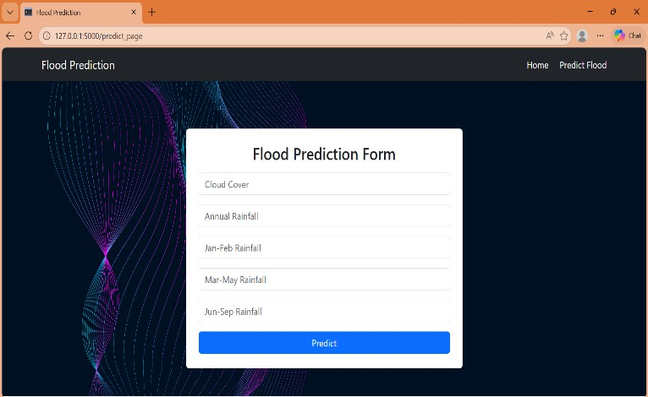

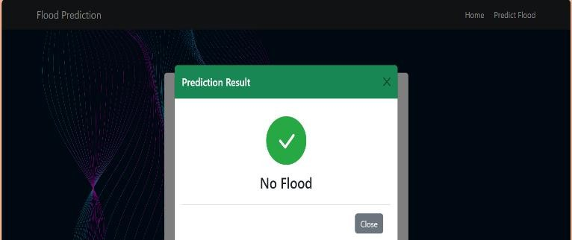
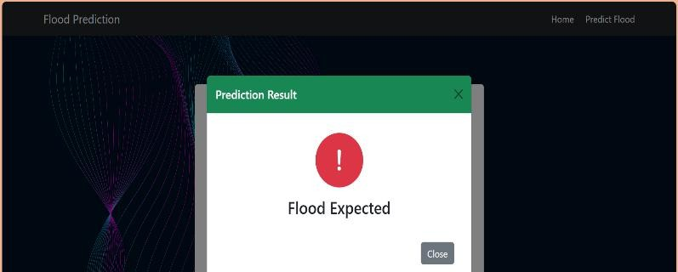
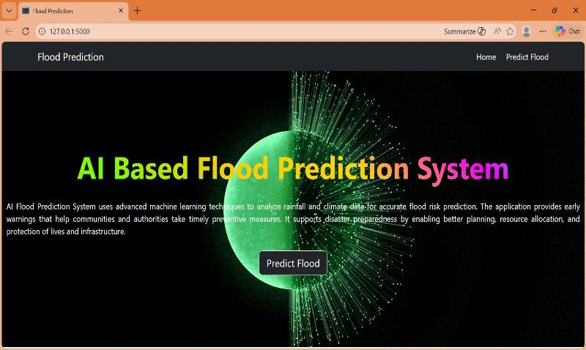
Figure 2: Home Page
Figure 2: Form to Read Data from Use

Comparison Graphs:

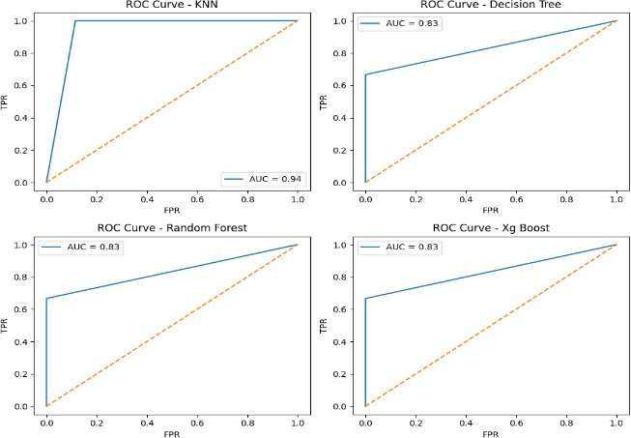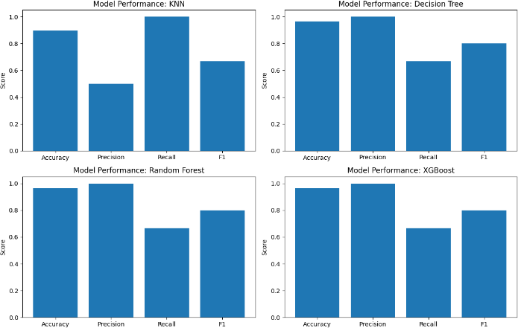
Figure c: Roc Curves for Models Figure 3: Performance Graphs (Bar)
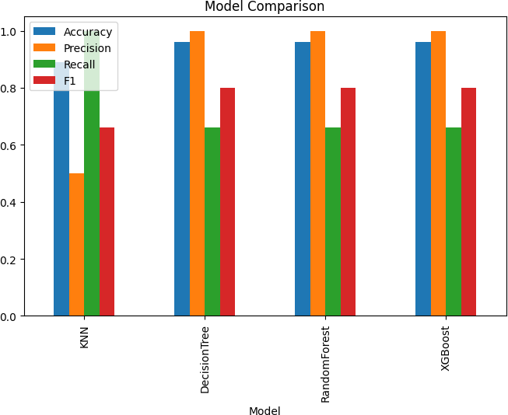
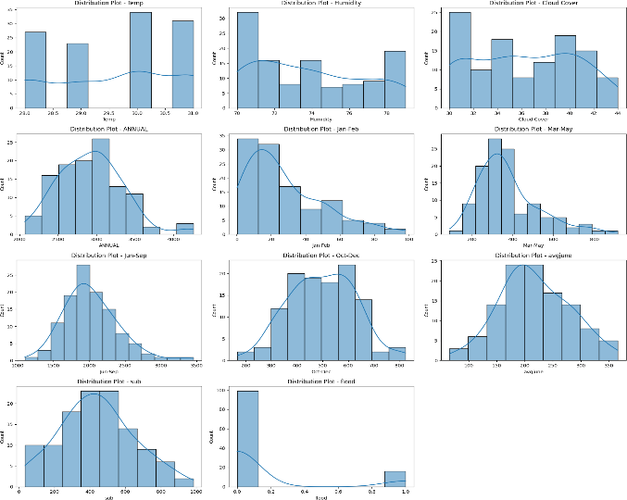
Figure 8: Models Comparison Figure S: Univariate Analysis

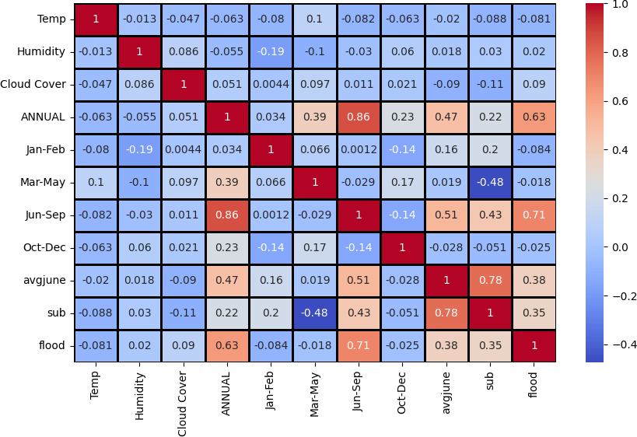
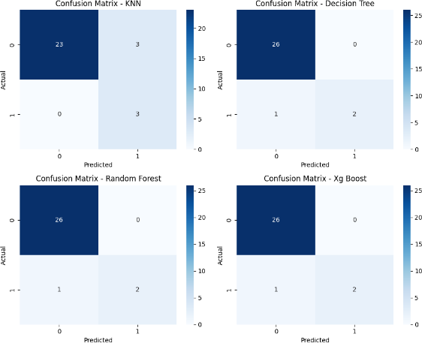
Figure 10: Heat Map Figure 41: Confusion Matrix

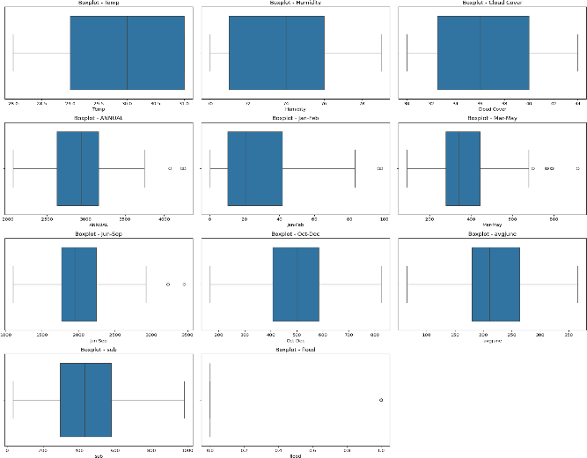
Figure 52: Multivariate Analysis

Table 1: Performance Evaluation Table
Model | Accuracy | Precision | Recall | F1-Score
KNN | 0.896552 | 0.5 | 1.000000 | 0.666667
Decision Tree | 0.965517 | 1.0 | 0.666667 | 0.800000
Random Forest | 0.965517 | 1.0 | 0.666667 | 0.800000
XGBoost | 0.965517 | 1.0 | 0.666667 | 0.800000

10. Advantages & Disadvantages

Advantages:
The Flood Prediction System provides early warning support by analyzing environmental parameters and predicting the likelihood of flood occurrence. This helps authorities and communities take preventive measures in advance, reducing potential damage and loss of life. The system is designed using a full-stack architecture, which allows seamless integration between the frontend interface and backend machine learning model. The user-friendly web interface enables non-technical users to easily input environmental data and obtain predictions without requiring specialized knowledge. Additionally, the model-driven approach improves prediction accuracy compared to traditional rule-based systems, and the digital deployment allows the application to be accessed from any location through a web browser.

Disadvantages:
Despite its benefits, the system has certain limitations. The prediction accuracy heavily depends on the quality and size of the training dataset. If the dataset is incomplete or biased, the model performance may decrease. The current implementation relies on static historical data and does not integrate real-time weather APIs, which may limit dynamic forecasting capability. Furthermore, the system requires proper hosting infrastructure for large-scale deployment, and model retraining is necessary when new environmental patterns emerge. These limitations highlight the need for continuous improvement and future enhancements to ensure reliable and scalable flood prediction.

Conclusion
The AI-based Flood Prediction System demonstrates how machine learning and full-stack web technologies can be combined to create an intelligent decision-support tool for disaster management. By analyzing rainfall and climate- related parameters, the system predicts the likelihood of flood occurrence and presents results through a simple and user-friendly web interface. The integration of frontend, backend, and predictive model components ensures smooth data flow, real-time prediction capability, and easy accessibility for users. Overall, the developed system provides an efficient, scalable, and practical solution that can assist authorities and communities in taking early preventive measures and improving disaster preparedness.

Future Scope
In the future, the system can be enhanced by integrating real-time weather and satellite data APIs to improve prediction accuracy and provide continuous monitoring. Advanced deep learning models and larger datasets can be incorporated to increase reliability across different geographical regions. Mobile application integration and automated alert systems such as SMS, email, or notification services can be developed to provide instant warnings to users. Additionally, the platform can be expanded into a comprehensive disaster-management dashboard that includes flood visualization maps, risk analysis tools, and government-level monitoring features, making the system more impactful for large-scale deployment.

APPENDIX

DataSet Link: https://www.kaggle.com/datasets/arbethi/rainfall-dataset

GitHub & Project Demo Link:
https://github.com/Syam7780/APSCHE-PROJECT/tree/main/Demo%20Video

